TIPS FOR USING THIS SIGNATURE TEMPLATE

- Add your personal information and contact info below. To preserve the formatting, either type the info into the text fields or Paste > Keep Text Only into each text field separately.
- To adjust the hyperlink to your participant NRSM URL, right-click on the image for the drop-down menu, then select Hyperlink > Insert your custom link.
- Copy the entire table (click the crosshairs at the top left of the Name).
- Paste > Keep Source Formatting into Outlook.

First and Last Name
Title/Department
XXX-XXX-XXXX
Email@address.com

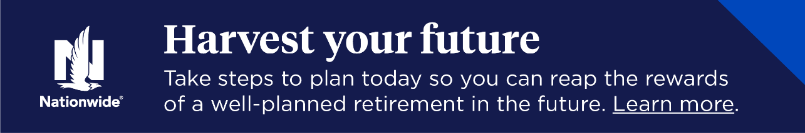

Above banner will link to: https://www.nationwide.com/personal/investing/retirement-plans/national-retirement-security-month/?utm_campaign=NRSM-2025&utm_medium=email&utm_source=Seismic&utm_content=NF:RPSL:ADVS:NI:na:PNM-23145AO

